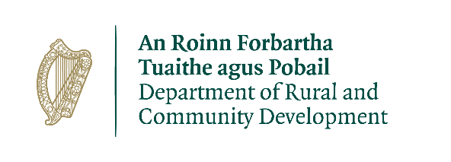

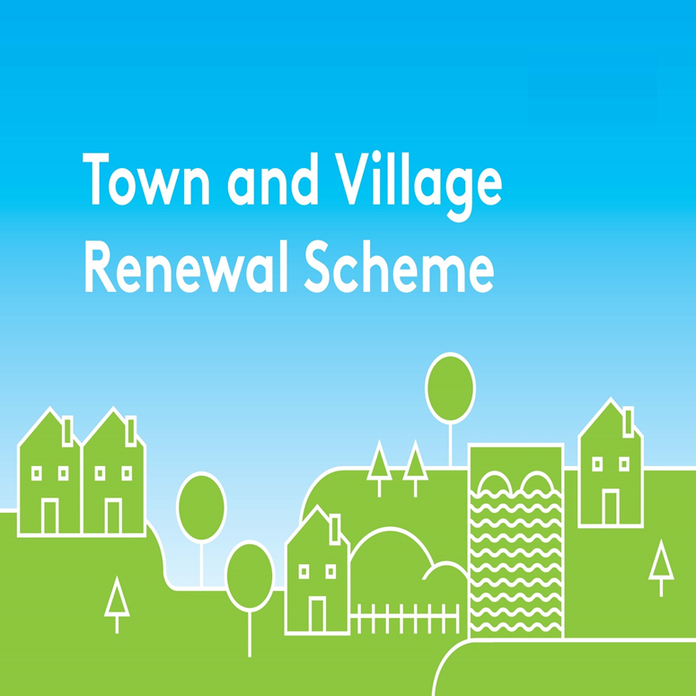

**2022 Application Form**

**Building Acquisition Measure**

All queries should be addressed to: [townandvillage@drcd.gov.ie](mailto:townandvillage@drcd.gov.ie)

**Application Reference No**

**APPLICATION FORM**

**This form should be completed by Local Authority personnel and returned by e-mail to** [**townandvillage@drcd.gov.ie**](mailto:townandvillage@drcd.gov.ie) **by close of business on 24th June 2022**

**Notes:**

**(a)** The number of applications that can be submitted by each Local Authority for grant funding (using main scheme form) is **6** (max)

* 5 applications of between €20,000 and €250,000
* 1 application of between €20,000 and €500,000

**(b)** Further streams of funding under the 2022 Scheme:

* 2 applications up to €50,000 each under the Project Development Measure (Using the separate Project Development Application Form)
* 1 application up to €50,000 for a specific County Marketing campaign (Separate form provided)
* Up to 2 applications for up to a total of €400,000 under the Building Acquisition Measure (This form)

**(c)** 1 of the applications from section (a) must be in respect of Towns/Villages that have not previously received funding under the Town & Village Renewal Scheme in the last 3 years. (Funding received under the 2020 Accelerated Measure will not be considered for these purposes).

**Name of Local Authority:**

**Amount of Grant Funding Requested :**

**Contact Name (Local Authority):**

**Contact email address:**

**Contact phone No:**

**Proposal Details:**

|  |
| --- |
| 1. **Please provide the Address of building (including Eircode) to be purchased and sale price. ( If there is a current for sale advertisement online please provide a link to the ad):** |

1. **Please provide a brief background to the selected building, (is it vacant and/or derelict? How long has it been vacant? Etc):**

|  |
| --- |
| 1. **What is the Local Authorities plan for the building? (Is the planned usage in line with Town and Village priorities? Are any proposed works, following purchase, achievable within the framework set out in the measure outline?)** |

|  |
| --- |
| 1. **Please confirm which of the following options the LA intends to follow: (to note failure to comply with this condition will deem funding ineligible and result in all funding being returned to the DRCD):** 2. The building will form the basis of an application under the 2023 or 2024 TVRS   **Or**   1. The building will be in the process of being developed for town regeneration purposes via the local authorities own resources or another relevant public funding stream by the end of 2024. |

1. **Financial Details:**

|  |  |
| --- | --- |
| Local Authority VAT No.: |  |
| Tax Registration No.: |  |
| Tax Clearance No.: |  |
| CHY Number (if applicable) |  |

1. **Timeline:**

On submission of this application the LA confirms that the purchase of the building will be completed and all relevant draw down information will be submitted to the Department by **11 November 2022**.

To Draw down Funds, LA’s will need to provide:

* An independent assessors’ report confirming value of building
* Building inspection report/ Building survey
* Proof sale has been legally agreed
* Proof of transfer of monies from the LA

Please ensure that this form is fully completed as an incomplete application may result in the project not being considered. Completed forms should be returned by e-mail to [townandvillage@drcd.gov.ie](mailto:townandvillage@drcd.gov.ie) **by** **24th June 2022.**

**Use of Data:**

The Department of Rural and Community Development (DRCD) is the Data Controller and the lawful basis for processing is ‘the performance of a task carried out in the public interest’.  Applications are submitted to the Department through the Local Authority for each area for this programme.  The Department may engage a Third party as a data processor.  The information on this Application Form will be used by DRCD for the purposes of processing the application. Further information may be sought by the Department to clarify aspects of the project proposal. The Department may draw on broader, more specialist expertise where required, and such information as considered necessary to complete an assessment of your application may be shared with those experts.

The Applicant, the Department and the Third party are subject to the data protection and privacy laws of Ireland and the EU, in particular the Data Protection Act 2018 and Regulation (EU) 2016/679, known as the EU General Data Protection Regulation (“GDPR”). Any personal information which you provide as part of the application process will be obtained and processed in compliance with Data Protection legislation.

The Department retains the right to disclose for the purposes of a request under the Freedom of Information Act 2014 or otherwise, in connection with the funded project(s) –

i.              any information supplied by the Applicant to the Department,

ii.            any relevant data gathered by the Department in administering grant aid to the project, except where the information is considered to be personal or commercially sensitive.

**Declaration by Local Authority:**

This declaration must be signed by an officer authorised at a senior level within the lead applicant organisation i.e. at least Director of Services level in a Local Authority.

I confirm that I have read and understood this document and declare that the particulars supplied in this application are true and correct and that –

* This project is eligible under the Town and Village Renewal Scheme criteria.
* The costings are accurate and reasonable.
* Match funding is available for the project and that evidence and source of the match funding is held on the project file.
* The project procurement process should be in line with EU Public Procurements Requirements (EU Directive 2014/24) and Public Procurement Guidelines.
* The project conforms to the LECP and other local or regional plans.
* That a consultation process was undertaken with representatives of the community or business interest of the town/village and that the project was identified through the consultation process undertaken.
* No funding has been allocated for the same works from any other public funding sources.

Proof of the above is not required at the time of application but must be available to the Department or its agents on request.

The Local Authority acknowledges the information regarding the use of data set out above and gives consent to the Department of Rural and Community Development for the sharing of all information, personal or otherwise, contained in this application and any attachments accompanying it, for the purposes of application processing in accordance with data protection legislation.

Signed on behalf of __________________________ (Local Authority)

Signature _______________________________

Name in Block Capitals_____________________

Position_________________________________

Date_____­­­­­­­­­­____