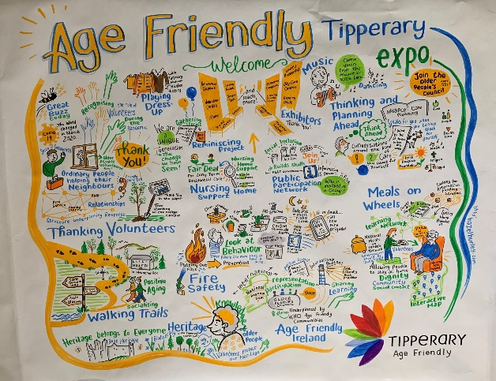

Tipperary Age Friendly EXPO 2023
When Thursday 22nd June 2023
Where TUS College Campus Nenagh Road Thurles
This is a free event and all are welcome
A Day to Showcase a range of Services and supports available for
Positive Ageing in County Tipperary
Refreshments Provided, Social Dancing on the Day
0818 06 5000 ask for Cliona Tobin, Fiona Crotty Angela Sheehan
agefriendly@tipperarycoco.ie

Transport to attend Tipperary Age Friendly will support community groups (whom are registered with Tipperary PPN) that wish to arrange transport to attend the event with a small grant to a maximum of €200 to offset the transport costs.
The community group arrange their own transport, confirm with Cliona, Fiona or Angela on the Age Friendly Community Staff and then claim the grant after the event

Confirmed Stands as at 14th June 2023
Acorn Cliffrum Media | North Tipperary Hospice & Roscrea Bereavement Support
Age Friendly Healthy Homes Tipperary | Order of Malta
Age Friendly Roscrea  Age Friendly Ireland | Rockwell Music Academy
ALONE | Safeguarding Team HSE
Bereavement Supports & Civil Ceremonies | SAGE Advocacy
Citizens Information Service | Silver Arch Family Resource Centre Nenagh
Dementia Friendly Thurles | Sláintecare Healthy Communities Clonmel
Energy Communities Tipperary Cooperative | Social Prescribing Service
Family Carers Ireland | South Tipperary Development Company
Fethard Horse Museum | Task community care
Golden Years Day Care & Cameo Care | Technological University of the Shannon
HALO Care | The Alzheimer Society
Health Matters | Thurles Men’s Shed
Home Instead | Tipperary Age Friendly
HSE CHO3 Integrated Care Programme for Older Persons Tipperary | Tipperary Children & Young Peoples Services Committee
HSE CHO5 Chronic Disease Hub Physio | Tipperary Civil Defence
HSE Health Promotion Unit | Tipperary County Council Environment Section
HSE Home Supports CHO3 | Tipperary County Council Housing Section
HSE Living Well | Tipperary County Council Library Service & Local Studies
HSE Living Well | Tipperary Education and Training Board
HSE Self-Management Support for Long Term Health Conditions | Tipperary Fire Service
Inclusion & Accessibility Labs | Tipperary Local Enterprise Office
Intreo Public Employment Service | Tipperary Local Link
LGBT+ Tipperary  LGBT Ireland | Tipperary Museum of Hidden History
Meals on Wheels | Tipperary Public Participation Network
Memory Technology Resource Rooms | Tipperary Sports Partnership
Millennium Family Resource Centre | Tipperary Tourism
Muintir na Tíre | Tipperary Volunteer Centre
North Tipperary Development Company | Tunstall Emergency Response

Confirmed Speakers as at 14th June 2023
Acorn Cliffrun Media | Task community Care
Age Friendly Healthy Homes Tipperary | Teresa Hennessey Mindfulness
ALONE | Tipperary Education and Training Board
An Garda Síochána Vulnerable Risk Register | Tipperary Fire Service
Fair Deal Scheme | Tipperary Public Participation Network (PPN)
Family Carers Ireland | Tipperary Volunteer Centre
James Duggan Storyteller | Tunstall Emergency Response
Memory Technology Resource Rooms
Neil Dennehy Mindfulness
Rockwell Music Academy (Singers)

