Message in a Bottle – It could save your life
What is Message in a Bottle?
The Lions Message in a Bottle is a simple idea that encourages people to keep their basic personal and medial details in a common place where they can easily be found in an emergency.
How Does it Work?
The information is kept in a bottle. The bottle is kept in the fridge, where the emergency services will expect to find it in the event of being called to your home.
They will know you have a bottle by the Message in a bottle green labels. One is fixed to inside your front door, one to the inside the rear door or main entrance to your house and the third sticker is on the door of your fridge. This ensures people are treated quickly which can save time and lives.

Medical Alert
If you wear of alert products you should continue to do so. The message in a bottle is not intended to replace these items,
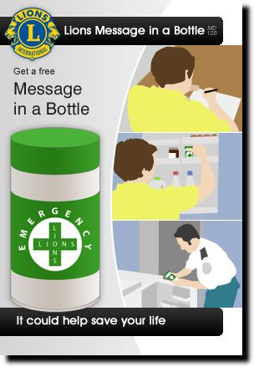
All Emergency services are aware of the scheme and will use this vital life saving information in the event of an emergency.

What information is needed?
The information is very basic but you may like to ask a relative, neighbour or carer to help you.
The details required are:
- Your full name and brief physical description
- Your doctors name, surgery address and telephone number
- A brief description of any medial conditions you are suffering from
- Allergies and allergic reaction to medication
- Location of our medication in your home
- The names, address and phone numbers of 2 people who may be contacted in an emergency
- Details of any pets that you may have on the premises
We also advise that you keep your repeat prescription list with you medication; this is of great help to paramedics.
A sheet is provided for you to complete together with 3 stickers.
1 sticker front door, 1 sticker back door, 1 sticker fridge door

Message in a Bottle project is brought to you by your local Lions Club and is supported by the following emergency services:
Ambulance - Fire Brigade - Gardaí - Medical Profession - Pharmacists
Message in a Bottle is a simple idea that encourages people to keep their basic personal and medical details in a common place, where, in cases of emergency, the Emergency Teams can easily find them. The information required is very basic but necessary.
The Personal Information Form is self explanatory; however you may like to ask a relation, friend, neighbour or carer to help you complete the form.
How does it work?
You are given a Bottle (plastic container) complete with the Personal Information Form and three self adhesive Green Crosses.
WHAT MUST YOU DO
- Complete all sections of the Personal Information Form.
- Put the completed form into the bottle.
- Close the lid and place the bottle onto the door shelf of your refrigerator.
- Attach one self-adhesive green cross onto the outside of the refrigerator door.
- Attach one green cross inside your front door.
- Attach one green cross inside your back door.
- ALL GREEN CROSSES SHOULD BE CLEARLY VISIBLE TO THE EMERGENCY SERVICES ENTERING YOUR HOME.
BE AWARE
A few minutes delay in emergency services finding your home could make the difference between life and death.
Give the emergency services a fighting chance to help you. Ensure that your house number or name can be clearly seen from the road.
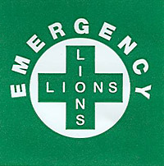
LIONS CLUBS INTERNATIONAL
www.lionsclub.ie supported by
Tipperary County Council

Your Personal Details
Surname |  | Please affix your photograph here
First Name
Date of Birth
Gender
Eye Colour
Hair Colour
PPS Number
Medical Card No
Religion
Address
 | Eircode
Telephone Number
Mobile Number
Your Pharmacy
Name
Phone or Mobile no
Your Doctor
Name
Telephone number

Special Details
Do you have hearing problems
Do you have speech problems
Do you have other problems
Current Medical Condition
For example, Asthama, Epilepsy etc
Allergies detail any allergy you suffer from
Where do you keep your medicine?
Which floor?
Which room?
Where in the room?

Do you have a donor card?
Yes | No

Do you have a pet
Yes | No

The following person relies on me for daily care. They will require somebody to care for them or collect them from school
Name
Address
Tel No | Home |  |  |  | Home
 | School |  |  |  | Mobile
Emergency Contact Persons
 |  | Person 1 |  |  |  | Person 2
Name
Relationship
Address
Tel No Home
Tel no Work
Tel no Mobile
Your Local Lions Club
Completed By
Date
All information on this form is correct to the best of my knowledge and I accept that it is my responsibility to ensure that this is kept up to date.
Signed
Relationship if any
Lions Club International and District 133 do not accept responsibility for personal details in this form or any additional paperwork included in the bottle

This project was supported by Tipperary Age Friendly, visit www.tipperarycoco.ie to find out more about Age Friendly

