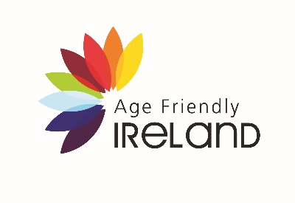
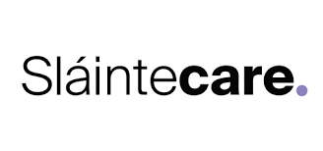
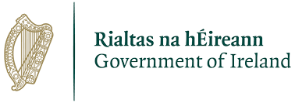

Healthy Age Friendly Homes Programme | Referral Form

The Healthy Age Friendly Homes Programme aims to support older people to live in their own home with dignity and independence, for as long as possible. The programme’s ambition is to enable everyone to live longer healthier lives by keeping care close to home and expanding the range of health and social care services in the community. It is about providing a range of alternatives for older people who may otherwise transition into long term residential care prematurely. To do this we have appointed a Local Healthy Age Friendly Homes Coordinator in nine local authorities (Cork County, Dublin City, Fingal County, Galway County & City, Limerick City & County, Longford County, South Dublin, Tipperary County, Westmeath County). Each Local Coordinator will case manage a support package for each person referred, linking the supports from the variety of public, voluntary, private and community agencies in the area.
The purpose of this referral is to identify an older person who could benefit from some extra help and support in order to stay living in their own home. The Local Coordinator will carry out a home based assessment and, in partnership with the older person, will identify and design a range of supports to enable the older person to continue living independently. This will not affect any current home help, medical card, pension or other services being received.
In order to see if this approach has been successful and to find out if this is a successful way of working, the local coordinator will gather information on the current housing, health, social and technology supports that the older person has/has not access to. This information will help the coordinator facilitate the older person to access a range of additional supports and information. Upon receipt of this referral each participant will receive an acknowledgement letter from their Local Coordinator outlining the next steps in the process.

Referrer Details (Block Capitals)
Name:
Occupation:
Date of referral:
Contact number:
Email address:
Signature:

Participant Details (Block Capitals)
Surname:
First Name:
Address
Eircode:
Date of Birth:
Mobile Number:
Landline:
First Language:
Interpreter required: | Yes No
I consent to my details being referred to a Local Coordinator for the purpose of participating in this Programme as outlined above. | Signature:

Additional Relevant Details (Block Capitals)
Reason for referral:
Any Relevant Medical, Family and Social History:
Additional Relevant information (including special needs, disabilities, clinical warnings):

For Internal use (Healthy Age Friendly Homes Programme - Local Coordinator)
Date referral received:

Referral acknowledged:

Please submit your completed form to
Postal Address: Healthy Age Friendly Homes, Tipperary County Council, Ballingarrane House, Clonmel, Co. Tipperary E91 E183.
Phone Number: 046-9032184
Email: aoife.dunphy@meathcoco.ie 