Aim of the Older People’s Council (OPC)
The Older Peoples Council is, in many ways, the key group of the Age Friendly Cities and Counties Programme. It brings the concerns and experiences of older people to the Age Friendly Alliance and the voice of older people to the decision making process of the Age Friendly Initiative throughout the County.
Purpose of the Group (OPC)
· To ensure that older people in Tipperary participate in the decisions which affect their lives.
· To provide an active channel of communication between the Older Peoples Council and the Age Friendly Initiative
· To provide the opportunity to comment on and influence Age Friendly City/County strategies, plans and projects
· To work cooperatively and represent the views of older people at local, regional & national level
· To identify and inform key actions for implementation with the Age Friendly City/County Alliance and strive to achieve a number of the objectives in the Age Friendly City/County Strategy
· To monitor the arrangements across the county in relation to implementation of the Age Friendly City or County Strategy
· To represent the views of older people, and keep older people up to date on key Age Friendly County initiatives and structures.
Membership of the Older Peoples Council (OPC)
Membership will be made up of individuals and group representatives who submit a membership form and will be representative of the city or county as a whole; both rural and urban and strive to achieve a gender balance across the county.
Executive of the Older Peoples Council (OPC)
The Executive will range from 12 to 20 including the Chair, Secretary with membership from the 5 Municipal Districts.
Executive Membership of the Older Peoples Council (OPC)
· To actively organise meetings and ensure widespread participation of older people within Older People’s Council.
To attend the Age Friendly Alliance meetings and report back to the Older People’s Council on the Age Friendly Strategy.
· To organise annual general meeting(s) and ensure all members receive updates and information in relation to the Age Friendly County Initiative.
Secretariat of the OPC
The Secretariat will be provided by Tipperary County Council and its purpose is to build, maintain and support the OPC and to take responsibility for general administration for meetings, venues etc
County Alliance
Tipperary County Age Friendly Programme will be led by an Alliance comprising the most senior decision makers from the key public, private and not-for-profit agencies involved in providing supports and services to older people e.g. Local Authority, HSE, Gardaí, TETB, Leader, Community and Voluntary Pillar, Chambers of Commerce, LEO and most importantly, a representative from the Older Peoples Council (OPC) or Executive, ensuring that the voice of the older person is heard loudly and clearly at the Alliance.
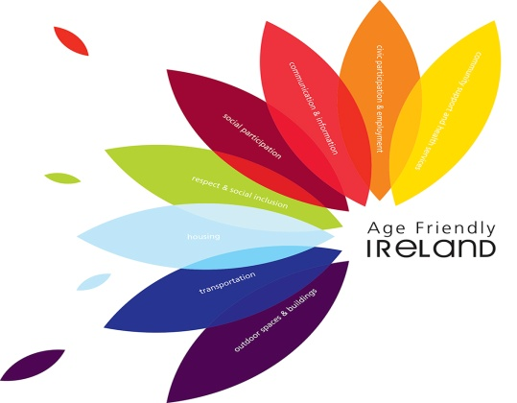

Tipperary Older Persons Council Expression of Interest

Name:
Address:
Eircode: |  | Telephone:
Email

If you are the representative of an organisation the Name of your Organisation :

I would like to receive details of meetings and activities of Tipperary Older People’s Council Yes No
I would like to vote for members of the Executive Committee of Tipperary Older People’s Council Yes No

I would like to be considered for election to the Executive Committee of Tipperary Older Peoples Council Yes No

Data Statement: I understand that the data given on this form will or can be used to send me information or keep me informed about the OPC/Age Friendly Alliance and its activities, and other information which OPC/Age Friendly Alliance considers may be of interest to me.
By ticking this box you give consent YES

If you would like your details removed at any time you may do so by emailing agefriendly@tipperarycoco.ie or in writing to Tipperary OPC c/o Tipperary County Council Ballingarrane House, Cahir Road, Clonmel, Co Tipperary.

Tipperary Older Peoples Council
Information and Expression of Interest form

Working to make Tipperary a great place to grow older in

Tipperary County Council,
Community and Social Inclusion,
Ballingarrane House,
Cahir Road,
Clonmel,
Co Tipperary E91E183

Phone 0761 06 5000
Email agefriendly@tipperarycoco.ie
Phone 0761 06 5000
Email agefriendly@tipperarycoco.ie
Tipperary County Council,
Community and Social Inclusion,
Ballingarrane House,
Cahir Road,
Clonmel,
Co Tipperary E91E183
Tipperary County Council,
Community and Social Inclusion,
Ballingarrane House,
Cahir Road,
Clonmel,
Co Tipperary E91E183
Tipperary County Council,
Community and Social Inclusion,
Ballingarrane House,
Cahir Road,
Clonmel,
Co Tipperary E91E183

