Press Release
Clonmel designated as one of the Sláintecare Healthy Communities Phase 1 locations

Healthy Communities is a new cross-government initiative to deliver increased health and wellbeing services to 19 community areas across Ireland. The programme will be delivered in partnership with the HSE, local authorities, local communities, statutory, voluntary and community groups. Clonmel has been identified as one of the 19 communities across the country and is one of 3 communities across the South East Community Health Network (CHO5). It will focus on the ED’s of Clonmel West Urban, Clonmel East Urban, Clonmel Rural and Inishlounaght.
The Healthy Communities in Clonmel will be a partnership to coordinate interventions that address the social determinants of health at a local level with community engagement
Tipperary County Council has been tasked at a local level with elements of the Sláintecare Healthy Communities Programme. Tipperary County Council, under the oversight of Tipperary Local Community Development Committee (LCDC), will establish a Local Implementation Team. This will be supported by a Local Development Officer employed by Tipperary County Council.
Pat Slattery, Director of Services Community & Economic and Chief Officer Tipperary LCDC “Tipperary county Council are very happy to partner in the Sláintecare Healthy Communities Programme to ensure the health and wellbeing needs of our communities are supported and that the Council can play a crucial role given our close connections to our communities and our important role in community development, housing, social supports, public space and the built environment."
Derval Howley Head of Service, Health and Wellbeing, South East Community Healthcare stated “the aim of the Healthy Communities Programme is to identify specific areas in which high risk factors to the health and wellbeing of the population are particularly prevalent, with a view to implementing targeted initiatives to tackle these challenges from within these communities. We are really pleased to see our partnership working and health and wellbeing programmes reach into the communities where they are most needed. The Healthy Communities Programme in Clonmel will be supported by areas-based teams and we are delighted to partner with Barnardos for Parenting Programmes and Clonmel Community Resource Centre for Social Prescribing Service”
Naomi Burke, Manager Clonmel Community Resource Centre, are delighted to host the new social prescribing service for Clonmel within the Healthy Communities Programme
Anna Henebry, Barnardos will partner with the HSE to deliver parenting programmes and noted that “this will provide families of greater need to access evidence-based parenting programmes in the Clonmel Catchment”

Clonmel was identified as one of the chosen 19 national communities. As part of the Department of Health’s investment in the 19 communities, a total fund of €4.75m has been made available, which equates to up to €250,000 per community. The focus of the Sláintecare Healthy Communities Community Enhancement Scheme is to support projects that will positively impact on the health and wellbeing of those who live within the 19 communities.
The Enhancement Scheme will support the development of Suir Island recreational gardens in Clonmel. Cllr Michael Murphy, Cathaoirleach Clonmel Borough District, “welcomes the investment for Green Heart of Clonmel. The development of the Suir Island Gardens will provide an amazing resource in the heart of our town of benefit to the citizens of Clonmel and its environs”
Sinead Carr, Director of Services and Manager Clonmel Borough District noted that “the opportunity to develop Suir Island lands will contribute to the realisation of the Master Plan as a key community and amenity resource in Clonmel. Tipperary County Council will provide match funding of €250,000 to deliver the recreational gardens and this is a significant investment in Clonmel, in addition to and complimenting, other capital projects in the town”

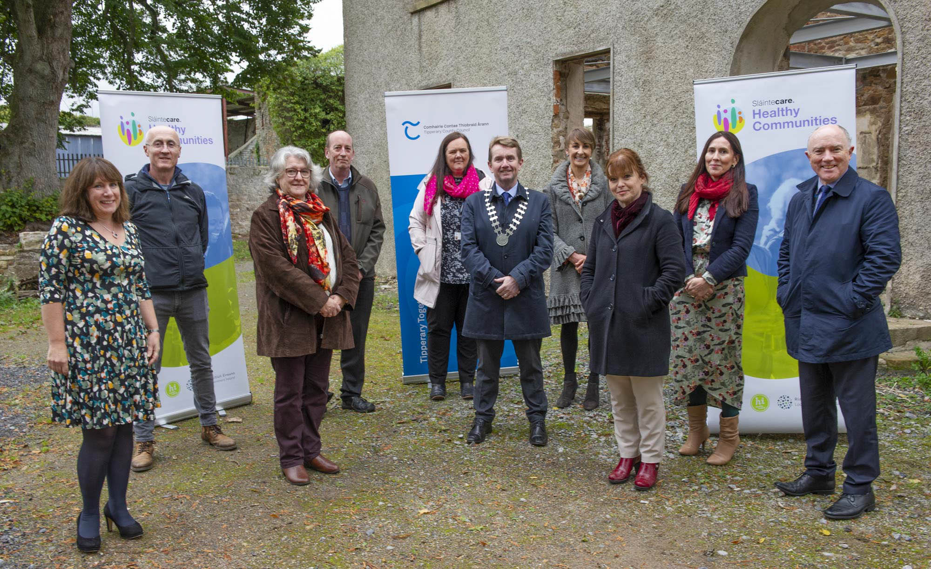
Pictured to acknowledge the announcement of Clonmel Healthy Communities and the Enhancement Scheme at Suir Island recently
L to R; Derval Howley, Head of Service Health and Wellbeing CHO5, Roger Noonan, Executive Engineer TCC, Naomi Burke Manager Clonmel Community Resource Centre, Jim Dillion Clonmel Borough District Administrator, Fiona Crotty Community TCC, Cllr Michael Murphy, Cathaoirleach Clonmel Borough District, Catherine O’Loughlin Health Promotion CHO5, Sinead Carr, Director of Services TCC, Anna Henebry, Barnardos Clonmel, Pat Slattery, Director of Services TCC.
End
Notes to editor

Core Elements of the Healthy Communities Programme include Key HSE Health and Wellbeing components:
Social Prescribing: A Social Prescribing link worker will provide interventions and referrals to community-based services in the statutory and non-statutory sector. Social prescribing offers GPs and other health professionals a means of referring people to a range of non-clinical community supports which can have significant benefits for their overall health and wellbeing and has been used to target social isolation, loneliness and emerging mental health difficulties.
Stop Smoking Advisor: A Stop Smoking Advisor will provide 1-1 support to quit smoking including the provision of NRT or other Stop Smoking medication. They will also promote and support the extension of smoke free environments. While Ireland has made great strides in reducing tobacco consumption, levels of smoking in Ireland continue require concerted effort to support the continued development of a tobacco-free society where people can live longer and healthier lives free from the detrimental effects of tobacco.
We Can Quit: We Can Quit is a friendly and supportive 12-week programme, providing group behavioural support, nicotine replacement therapy and other stop smoking medication, to help attendees quit smoking and stay quit for good. This group programme has been proven to support people around their smoking by utilising peer and social support as well as professional input.
Parenting Programmes: Parenting Programmes will provide families with greater access to evidence-based parenting programmes. Parenting programmes have been shown to be one of the most effective ways to improve child and parental mental health and wellbeing.
Healthy Food Made Easy: The Healthy Food Made Easy (HFME) programme will provide a user-friendly nutrition and cookery course that helps people increase their skills to implement a healthy diet, plan meals on a budget and make easy to cook meals.
MECC: The Making Every Contact Count (MECC) programme will work with local health professionals to ensure they have the up-to-date skills to deliver brief interventions and advice for all patients regarding healthy behaviours (smoking, alcohol use, physical activity, diet and nutrition). This will see an increase in service users and patients being advised to make healthy lifestyle choices and directed to supporting resources and programmes to do so.
Community Food and Nutrition Workers: With a remit to build capacity, knowledge and skills across communities and to work with local statutory and voluntary partners to improve the food environment and address food poverty and activate agreed national campaigns. These workers will be funded by HSE Health and Wellbeing and employed by community organisations.
Key local authority components: Each of the respective local authorities will coordinate and support the SHCP with the Local Community Development Committees and their existing Healthy City and Healthy County plans as well as recruiting Healthy Community Local Development Officers to coordinate activity from a local authority perspective. This increase in resource for local authorities is aimed at integrating the health and wellbeing agenda with their broader agenda and supporting a social determinants approach to health inequalities.
Local Partner components: Key to local operational delivery are the locally commissioned community partners such as the Local Partnership Companies, Family Resource Centres and others who have an existing reach and engagement into these communities. The Healthy Food Made Easy (HFME), the Community Food & Nutrition Worker as well as the Social Prescribing initiatives will be delivered by local community agencies such as these to build on existing programmes and assets at community level.

For further information in relation to the Healthy Communities Programme Clonmel please don’t hesitate to contact Fiona Crotty fiona.crotty@tipperarycoco.ie or on 087 1252938.

