

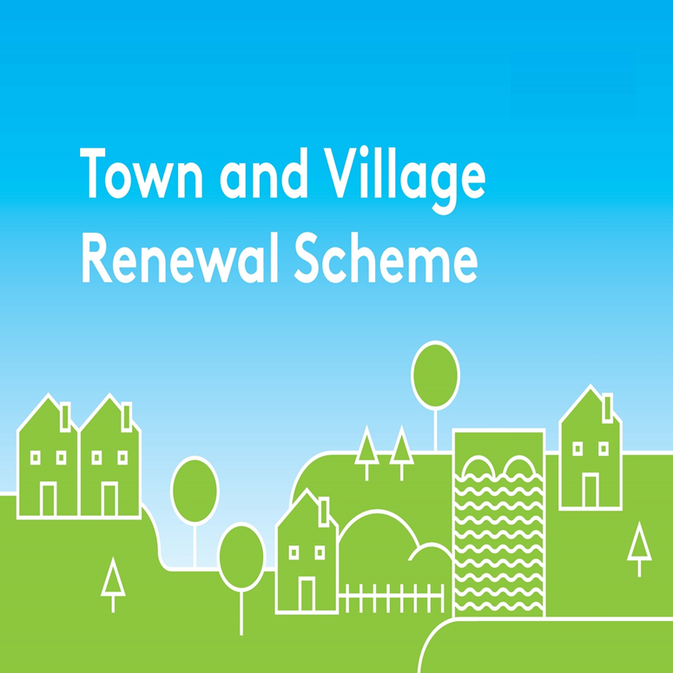

**2023 Application Form**

Please complete a separate application form in respect of each proposal.

All queries should be addressed to: [townandvillage@drcd.gov.ie](mailto:townandvillage@drcd.gov.ie)

**Application Reference No**

**APPLICATION FORM**

**This form should be completed by Local Authority personnel and returned by e-mail to** [**townandvillage@drcd.gov.ie**](mailto:townandvillage@drcd.gov.ie) **by close of business on 10th November 2023**

**Notes:**

The number of applications that can be submitted by each Local Authority for grant funding is 5 per Local Authority (or up to 6 where an inhabited offshore island is applicable). Each application should be submitted on a separate application form.

* 4 applications of between €20,000 and €250,000
* 1 application of between €20,000 and €500,000

One additional application, up to €250,000 will be accepted in respect of projects for an inhabited offshore island. (See Scheme outline for list of eligible islands)

**1 of the applications for funding under the Main Scheme** must be in respect of Towns/Villages that have not previously received funding under the Town & Village Renewal Scheme in the last 3 years.

**Name of Local Authority:**

**Town/Village covered**:

**Postal Address of project:**

**Eircode or XY (ITM format)**

**Coordinates of the project:**

**Amount of Grant Funding Requested[1] :**

**Contact Name (Local Authority):**

**Contact email address:**

**Contact phone No:**

**Project Details:**

|  |
| --- |
| 1. **Project description (max 30 words) – Details may be used for Press Release / website:** |

1. **Project Details (Max. of 300 words, To include bullet point detail of project elements)**

A detailed project proposal may be appended to this application. (Maximum 2 Pages for grant funding up to €250,000 and max of 5 pages for grant funding from €250,000 to €500,000):

**3. Permissions and Planning**

**(a)** Does the proposed project involve works to a building/property or lands that are not in the ownership of the Local Authority or Local Community Partner? If yes, provide details of the current owner/s.

**(b)** If the building/property is not in the ownership of the Local Authority or community group partner, has permission has been granted by the owners to carry out the proposed works? A lease must be in place at project commencement date and for a minimum of 15 years from project completion date. Is this in place?

**(c)** Are all appropriate assessments, screenings and planning permissions in place?

|  |
| --- |
| 1. **Has this town/village received public funding previously e.g. REDZ, T&V, CLÁR, ORIS, RRDF, LEADER, CCIF, CRF etc.? If so, please list by scheme, year and funding amount.** |

|  |
| --- |
| 1. **Explain the rationale for the choice of Town/Village. To Include**: identify existing assets, amenities, accessibility, environmental aspect, retail mix, etc. Identifying deficits to be addressed, or opportunities to be built on.  How will the project make a positive impact on the town/village?  **(Max. of 300 words). (If a health check or TCF plan has been developed for this town, please append this to the application)** |

|  |
| --- |
| **(a) Please provide details of the community consultation/engagement with local groups and stakeholders to develop this application.**  **(b) Please detail how the scheme was advertised.** |

|  |
| --- |
| 1. **Are there any other applications pending for public funding for this project? (e.g. Active Travel or Destination Towns, etc)** |

|  |
| --- |
| 1. **If this town/village is also the subject of an RRDF application, explain the rationale for submitting this application to the Town and Village Renewal Scheme and how this links with the RRDF application.** |

|  |
| --- |
| 1. **Who will be implementing the project?** Please provide details of other stakeholders involved. (*Please note per the scheme outline, Section 8 Local Authority Costs, where works are to be undertaken in-house by the LA, a breakdown of these costs must be included in the application form and a rationale provided for same. Where LA staff costs are included they must be proportionate to the overall cost of the project, and identified at application stage*) |

|  |
| --- |
| 1. **To what extent will this project address the United Nations Sustainable Development Goals (SDGs)?** |

1. **Financial Details:**

|  |  |
| --- | --- |
| Local Authority VAT No.: |  |
| Tax Registration No.: |  |
| Tax Clearance No.: |  |
| CHY Number (if applicable) |  |

1. **PROJECT COSTINGS:**

Please provide detailed breakdown of all elements of the proposed works including any administration/other fees/costs/signage:

(please add additional rows for costs as required)

|  |  |
| --- | --- |
| **Project Element** | **Estimated Cost (inclusive of VAT)** |
| **1. e.g. signage** | € |
| **2.** | € |
| **3.** | € |
| **4.** | € |
| **Local Authority Costs, (if applicable)** |  |
| **1.** | € |
| **2.** | € |
| **Total Project Cost** | € |
| **Grant Aid amount sought:**  (Max of 90% of total project costs, 95% for NW Region counties) | € |
| **Match Funding: (Min 10% of total cost, 5% for NW Region counties)**  **To be supplied by:** | € |
| **Any other relevant information:** |  |

1. **Timeline:**

Provide a timeline for commencement and completion of the project.

Any project that has not commenced by the end of the agreed 18 month timeframe will automatically be decommitted.

|  |  |  |
| --- | --- | --- |
| Commencement date | Completion Date | Indicative time frame (weeks/months): |
|  |  |  |

The following forms should be returned to the Department by **10th November 2023**:

(i) Application form

(ii) Application Overview sheet and

(iii) The Expression of Interest Overview sheets.

Please ensure that these forms are fully completed as an incomplete application may result in the project not being considered. Completed forms should be returned by e-mail to [townandvillage@drcd.gov.ie](mailto:townandvillage@drcd.gov.ie) **by 10th November 2023.**

**Use of Data:**

The Department of Rural and Community Development (DRCD) is the Data Controller and the lawful basis for processing is ‘the performance of a task carried out in the public interest’.  Applications are submitted to the Department through the Local Authority for each area for this programme.  The Department may engage a Third party as a data processor.  The information on this Application Form will be used by DRCD for the purposes of processing the application. Further information may be sought by the Department or the third party processor to clarify aspects of the project proposal. The Department may draw on broader, more specialist expertise where required, and such information as considered necessary to complete an assessment of your application may be shared with those experts.

The Applicant, the Department and the Third party are subject to the data protection and privacy laws of Ireland and the EU, in particular the Data Protection Act 2018 and Regulation (EU) 2016/679, known as the EU General Data Protection Regulation (“GDPR”). Any personal information which you provide as part of the application process will be obtained and processed in compliance with Data Protection legislation.

The Department retains the right to disclose for the purposes of a request under the Freedom of Information Act 2014 or otherwise, in connection with the funded project(s) –

i.              any information supplied by the Applicant to the Department,

ii.            any relevant data gathered by the Department in administering grant aid to the project, except where the information is considered to be personal or commercially sensitive.

**Declaration by Local Authority:**

This declaration must be signed by an officer authorised at a senior level within the lead applicant organisation i.e. at least Director of Services level in a Local Authority.

I confirm that I have read and understood this document and declare that the particulars supplied in this application are true and correct and that –

* This project is eligible under the Town and Village Renewal Scheme criteria.
* The costings are accurate and reasonable.
* Match funding is available for the project and that evidence and source of the match funding is held on the project file.
* Evidence of ownership (if applicable) or the consent of the landowner is on the project file.
* The project procurement process should be in line with EU Public Procurements Requirements (EU Directive 2014/24) and Public Procurement Guidelines.
* The project conforms to the LECP and other local or regional plans.
* That a consultation process was undertaken with representatives of the community or business interest of the town/village and that the project was identified through the consultation process undertaken.
* No funding has been allocated for the same works from any other public funding sources.

Proof of the above is not required at the time of application but must be available to the Department or its agents on request.

The Local Authority acknowledges the information regarding the use of data set out above and gives consent to the Department of Rural and Community Development for the sharing of all information, personal or otherwise, contained in this application and any attachments accompanying it, for the purposes of application processing in accordance with data protection legislation.

Signed on behalf of: __________________________ (Local Authority)

Signature: _______________________________

Name in Block Capitals: _____________________

Position: _________________________________

Date: ____________________

**Indicative list of eligible projects (not exhaustive)**

* Regeneration projects that assist in revitalising our rural towns and villages, in line with the *Town Centre First* Policy, through planned and sustainable regeneration and development projects that will drive greater economic activity and footfall, address vacancy and dereliction and ensure the re-use of heritage and other existing buildings; these projects should be identified in Town Centre First Plans, town and village masterplans (or similar) developed in collaboration with the local community, businesses and the other relevant stakeholders in the town or village.

*(Footpath development/improvement projects or similar will not be supported as these can be financed by Local Authorities directly or through the Active Travel Investment Programme.)*

* In recognition of the need for outdoor community spaces one application may be used for the acquisition of land in town centres which supports Local Authorities for the development of town regeneration / community focused projects (to include possibly town parks / plazas, the development of surrounding properties already in Local Authority ownership etc). This is a new option introduced under the 2023 TVRS. **Note:** if applying for land acquisition the local authority should confirm that acquisition of this land under TVRS does not impact upon potential use of this land for housing purposes etc.
* Renovation or refurbishment to existing community centres (where there is a clearly identified need / rationale) (additional questionnaire applies)
* (Funding for new build community centres is available under an integrated programme of supports for the development and refurbishment of community centres across other schemes within the Rural Development Investment Programme.)
* Projects to support vibrant and sustainable island communities on Ireland’s inhabited offshore islands. (Donegal, Sligo, Mayo, Galway, Cork)
* Projects to support the establishment of town or village centre markets (e.g. farmers markets, open-air markets, local trader markets, artisan markets or similar) – i.e. ground works, provision of stalls, equipment, and services provision. Markets must be built on ethical and sustainability principles to ensure longevity and must be developed with high visibility and improved public realm which will attract a high level of footfall.
* Projects to develop town / village centre plazas, public outdoor dining spaces, parks, green spaces (including allotments and community gardens) and recreational spaces/amenities (to include outdoor sports facilities such as skate parks, basketball courts, tennis courts, etc.) in town centres to make them vibrant hubs for community enjoyment, and to increase footfall for local businesses. Only applications for funding for public or community owned or leased properties and/or lands will be considered. Projects must be located in the town or village centre. *(Please note, leases for all projects must be in place for a minimum of 15 years – see Funding Conditions below)*
* Projects to support the upgrade and enhancement of shopfronts and street facades (including murals) in towns and villages. Local authorities are encouraged to engage with local business and property owners to examine how group projects can add colour and vibrancy to main streets.
* Projects that bring vacant and derelict buildings and sites back into use as multi-purpose spaces. This can include **both the purchase and renovation** of vacant and derelict buildings. This includes former state owned property that is no longer being used and is made available to the community. Multi-purpose use includes enterprise spaces, arts, tourism, youth hubs and other community uses.
* Projects that bring vacant properties in Town Centres back into use as Remote Working Hubs. Successful applicants who receive funding for remote working facilities will be required to commit to a three year membership of the National Hub Network.

*N.B. If you intend to apply for funding to establish a hub (see Appendix 1 for hub classification guide) you will be required to clearly demonstrate that there is a demand for such a facility and that clear additionality will be delivered taking account of the significant level of public investment in this area to date. Any such applications will be required to provide information in relation to this. This is designed to ensure that there is a sound business case for a new hub.*

* Marketing campaigns targeted at attracting remote workers and mobile talent to their county/region; and promotion of specific town/villages to attract new customers and/or business investment.
* Projects that support and enhance the night-time economy in line with emerging recommendations from the Night-Time Economy Taskforce.
* Enhancement of heritage assets (e.g. local museums/tourism attractions focused on historical aspects of the area, heritage sites/buildings, etc.) located in towns and villages, including energy efficiency measures.

1. Please keep responses to word limits on application form. Where grant funding of €250,000 to €500,000 is being requested an additional submission of max 5 pages to support the application may be submitted.