Designated Public Officials in
Tipperary County Council

Elected Members
Cahir Local Electoral Area

Councillor | Political Party (if any)
Mr. Micheál Anglim | Fianna Fáil
Mr. Andy Moloney | Non Party
Ms. Marie Murphy | Fine Gael
Ms. Máirín McGrath | Non Party

Carrick-on-Suir Local Electoral Area

Councillor | Political Party (if any)
Mr. Kieran Bourke | Fianna Fáil
Mr. David Dunne | Sinn Féin
Ms. Imelda Goldsboro | Fianna Fáil
Mr. Mark Fitzgerald | Fine Gael
Mr. Kevin O’Meara | Non Party

Cashel-Tipperary Local Electoral Area

Councillor | Political Party (if any)
Mr. Tony Black | Sinn Féin
Mr. Declan Burgess | Fine Gael
Mr. John Crosse | Fine Gael
Mr. Michael FitzGerald | Fine Gael
Ms. Mary Hanna Hourigan | Fine Gael
Mr. Roger Kennedy | Fianna Fáil
Ms. Annemarie (Shiner) Ryan | Non Party

Clonmel Local Electoral Area

Councillor | Political Party (if any)
Ms. Siobhan Ambrose | Fianna Fáil
Mr. Niall Dennehy | Non Party
Mr. Pat English | Workers and Unemployed Action
Mr. John Fitzgerald | Fine Gael
Mr. Richie Molloy | Non Party
Mr. Michael Murphy | Fine Gael

Nenagh Local Electoral Area

Councillor | Political Party (if any)
Mr. Gerard Darcy | Fine Gael
Mr. Joe Hannigan | Non Party
Mr. Hughie McGrath | Non Party
Mr. Seamus Morris | Non Party
Mr. Michael O’Meara | Non Party

Newport Local Electoral Area

Councillor | Political Party (if any)
Ms. Fiona Bonfield | Labour
Dr. Phyll Bugler | Fine Gael
Mr. John Carroll | Fianna Fáil
Mr. John Rocky McGrath | Non Party

Roscrea-Templemore Local Electoral Area

Councillor | Political Party (if any)
Mr. Noel J. Coonan | Fine Gael
Mr. Shane Lee | Non Party
Mr. Eddie Moran | Non Party
Mr. Michael Smith | Fianna Fáil

Thurles Local Electoral Area

Councillor | Political Party (if any)
Mr. Seamus Hanafin | Fianna Fáil
Mr. Micheál Lowry | Non Party
Mr. Peggy Ryan | Fine Gael
Mr. Jim Ryan | Non Party
Mr. Sean Ryan | Fianna Fáil

Designated Public Officials in
Tipperary County Council
Executive
Name |  | Position
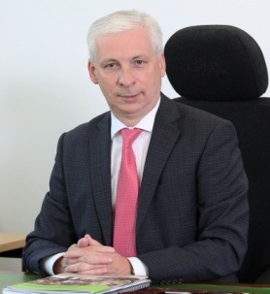 | Joe MacGrath | Chief Executive
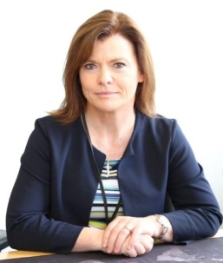 | Sinead Carr | Director of Services  - Housing  - Ukrainian Refugee Accommodation Response  - Deputy Chief Executive  - Clonmel Borough District
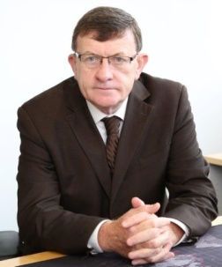 | Marcus O'Connor | Director of Services  - Roads and Transportation  - Active Travel  - Health and Safety  - Nenagh Municipal District
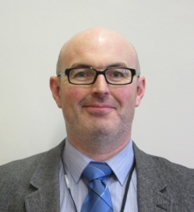 | Eamon Lonergan | Director of Services  - Climate Action and Environmental Services  - Water Services  - Human Resources  - Thurles Municipal District
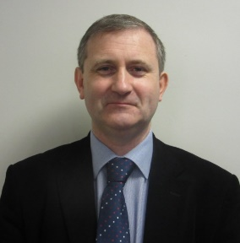 | Anthony Coleman | Director of Services  - Local Authorities Waters Programme (LAWPRO)  - Shared National Local Authority Services
 | Mark Connolly | Head of Finance  - Finance  - Information Technology  - Motor Taxation
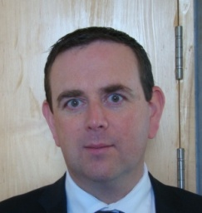 | Brian Beck | Acting Director of Services  - Economic, Community and Rural Development  - Corporate Services  - Library/Cultural Services/Biodiversity  - Carrick-on-Suir Municipal District
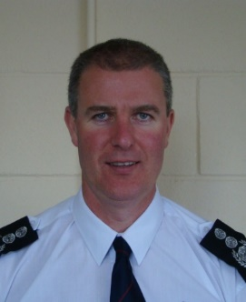 | Dave Carroll | Acting Director of Services  - Planning and Development (including Town Centre First and Just Transition)  - Emergency Services and Emergency Planning  - Tipperary/Cahir/Cashel Municipal District

