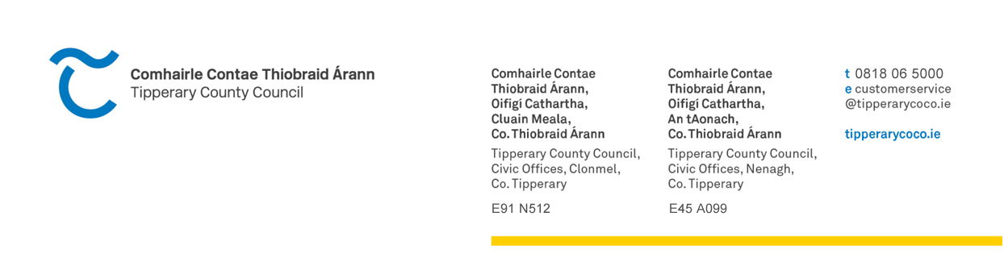 CLUBS/ORGANISATIONS CONTRIBUTION GRANT SCHEME
APPLICATION FORM 2024
- CLUB NAME: _______________________________________
- CONTACT PERSON: _______________________________________
ADDRESS: _______________________________________
_______________________________________
Tel No:_________________________________
E-mail:_____________________________
Website: ___________________________
Facebook Page:______________________
- BRIEF DESCRIPTION OF______________________________________
ACTIVITIES OF CLUB/
ORGANISATION: ________________________________________
________________________________________
________________________________________
________________________________________

- TOTAL CURRENT

MEMBERSHIP

- HAS YOUR CLUB/ORGANISATION REGISTERED WITH THE PUBLIC PARTICIPATION NETWORK (PPN)
Yes No
If not, it is a requirement that you register with the PPN - registration can be done on line at www.ppntipperary.ie or alternatively by contacting 0504 61014

- HAS YOUR CLUB RECEIVED:
- LOCAL AUTHORITY (COUNTY COUNCIL/MUNICIPAL DISTRICT) FUNDING IN THE LAST 3 YEARS

YES/NO: __________________________

IF YES PLEASE PROVIDE DETAILS:__________________________

___________________________________________________________

___________________________________________________________

- STATE FUNDING IN THE LAST 3 YEARS

YES/NO: __________________________

IF YES PLEASE PROVIDE DETAILS:__________________________

___________________________________________________________

___________________________________________________________

- HOW LONG HAS THE CLUB/ORGANISATION BEEN IN EXISTENCE:

_____________________________________________________________

- WHAT ARE THE KEY SOURCES OF FUNDING FOR YOUR CLUB/ORGANISATION:

________________________________________________________________________________________________________________________________________________________________________
- DOES YOUR CLUB/ORGANISATION OWN FACILITIES – IF SO, GIVE DETAILS:

________________________________________________________________________________________________________________If yes, are the facilities open to other groups/clubs?: ________________________________________________________
- IS MEMBERSHIP OF THE CLUB/ORGANISATION OPEN OR CONFINED?
________________________________________________________
GIVE DETAILS OF ANY CRITERIA REQUIRED:
________________________________________________________________________________________________________________
- DO YOU CURRENTLY HAVE ANY OTHER APPLICATION FOR FUNDING WITH TIPPERARY COUNTY COUNCIL, IF SO PROVIDE
DETAILS:

________________________________________________________________________________________________________________________________________________________________________

- IF YOUR CLUB/ORGANISATION SATISFIES ANY OF THE FOLLOWING CRITERIA PLEASE PROVIDE RELEVANT INFORMATION:

- CLUB/ORGANISATION IN INITIAL STAGES OF DEVELOPMENT

__________________________________________________________________________________________________________________________________________________________________
______________________________________________________

- CLUB/ORGANISATION FULFILS PARTICULAR SOCIAL INCLUSION ROLE
__________________________________________________________________________________________________________________________________________________________________
______________________________________________________

- CLUB/ORGANISATION UNDERTAKING DEVELOPMENT WORKS OR HAVE DONE DO WITHIN LAST 12 MONTHS

__________________________________________________________________________________________________________________________________________________________________
______________________________________________________

- ARE THERE ANY REASONS WHY THIS APPLICATION SHOULD BE CONSIDERED AS HAVING SPECIAL MERIT E.G. SPECIFIC COMMUNITY BENEFIT, EXCEPTIONAL CIRCUMSTANCES, ETC.? IF SO PLEASE OUTLINE

______________________________________________________________________________________________________________________________________________________________________________________________________________________________________________________________________________

Closing date:-Friday 15th March, 2024 at 4.30 p.m.

Send completed form to:- Nenagh Municipal District, Tipperary County Council, Civic Offices, Limerick Road, Nenagh, Co. Tipperary

Applications should be accompanied by a current bank statement

All applicants should note that there will be only two scheduled payment dates for these schemes. Full documentation required must be submitted in advance of these dates in order for payment to be made.

Receipt of funding in previous years is no guarantee of funding in 2024. Likewise allocation of funding in 2024 is no guarantee of funding in future years.

