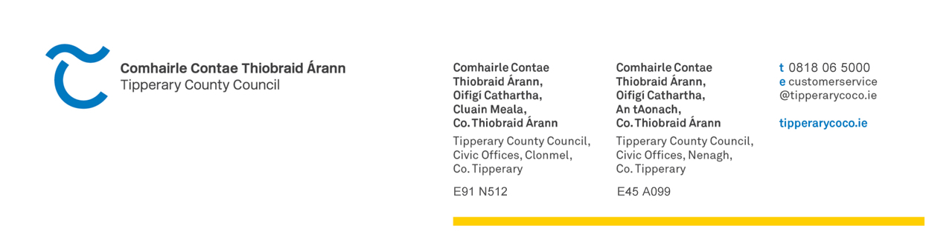

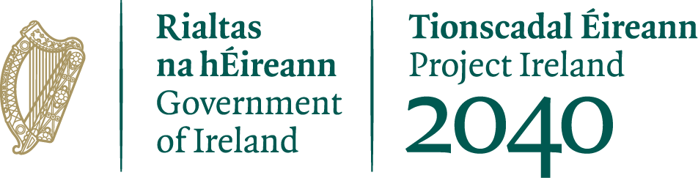
22nd of December 2025

Press Release – Tipperary County Council

Funding Awarded under the 2025 Town & village Renewal Main Scheme & Project Development Measure.

Minister for Rural and Community Development and the Gaeltacht, Dara Calleary TD has announced funding of €912,950 for 3 projects across Co. Tipperary under the Town & Village Renewal Main Scheme and €100,000 for 2 projects under the Town and Village Renewal Project Development Measure.

The funding, which is provided under the Town and Village Renewal Scheme (TVRS), is being invested in projects that will rejuvenate town centres, drive economic growth and town footfall, combat dereliction and vacancy, develop pedestrian zones and outdoor spaces and boost tourism in rural Ireland. The successful projects are as follows:

Main Scheme  Project Name | Project Description | Grant Allocation
Cashel Town Park | Phase 2 development of the Town Park aims to provide a high-quality park and public amenities in the centre of the town to include further development of the Boardwalk, construction of grass and gravel paths and landscaping to the west of the Bishops Walk. | €300,000
Nenagh Gaol | Renovation of 3-storey vacant Gaol lock to provide a visitor experience stimulating economic and social regeneration of the Historic & Cultural Quarter. | €500,000
Templemore Town Park | Enhance the Town Parks local biodiversity and improve the overall visitor experience, to include the development of the car park, resurfacing of pathways, planting of native hedgerows, and the introduction of a tranquil picnic area. | €112,950
Project Development Measure  Project Name | Project Description | Grant Allocation
Carrick on Suir Duck Pond | To transform the under-utilised Duck Pond Area into a publicly accessible, environmentally sustainable amenity. Planning and design stages to progress towards capital investment readiness. | €50,000
Golden | Enhance Golden Island and adjoining site and properties to support the development of the village as a sustainable rural community and deliver a focal point where people can meet and relax along the banks of the River Suir. | €50,000

Commenting on the announcement, Ms. Sinead Carr, Chief Executive of Tipperary County Council stated that "Tipperary County Council welcomes the allocation of €1,012,950 under the Town Renewal Scheme. This funding represents a significant investment in the heart of our rural communities, supporting town-centre regeneration and breathing new life into our streetscapes. These projects will not only enhance the quality of life for residents but will also attract further economic and social activity, ensuring our towns are vibrant, sustainable places to live, work, and visit.
Tipperary County Council wishes to sincerely thank our elected members for their continued support in providing the match funding for these projects. Their commitment enables us to draw down significant Government funding, ensuring that these transformative initiatives can be delivered for the benefit of our communities."

Ends

