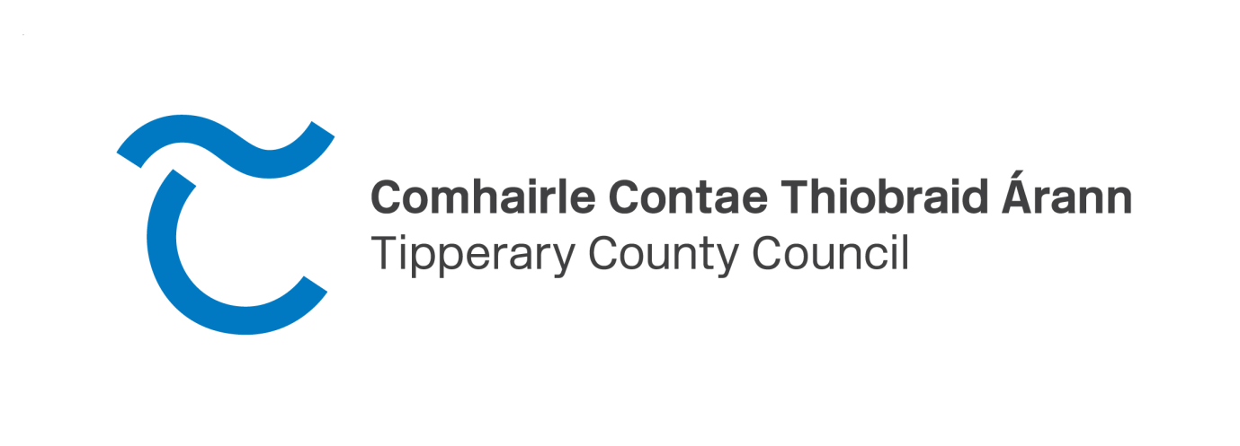

Summary of Social Housing Needs Assessment
In accordance with Section 21 of the Housing (Miscellaneous Provisions) Act 2009, Tipperary County Council has been instructed by the Department of Housing, Planning, Community & Local Government to carry out a Housing Needs Assessment for 2026
Selected Social Housing Applicants in Tipperary will have to declare if they wish to remain on the local authority housing list as part of a Department of Housing, Planning, and Local Government assessment to determine a true and accurate need across the country. Tipperary County Council will be writing to all relevant applicants to confirm their current housing need and they will be required to submit the completed application form.
Applicants will also be requested to submit supporting documentation in the event of a change of circumstances including evidence of income since they were last assessed. All applicants must return the form by Friday 17th July 2026.
Please note: Under the departmental directive, failure to submit fully completed SSHA 2026 form, along with relevant documentation, will result in the file being closed and the applicant being removed from the housing list.
Those assessed as part of the SSHA in 2025 will not be included in this year’s review. Also, all HAP tenants, RAS tenants and applicants approved for a social housing transfer are excluded from this review.
All elected representatives have been notified of the Summary of Social Housing Assessment and are encouraged to remind any applicants of its existence and that it is imperative to complete the form and return it to avoid losing their place on the list.
All applicants must return the form by Friday 17th July 2026 to the following addresses:
Housing Section or Housing Section
Tipperary County Council Tipperary County Council
Civic Offices Civic Offices
Clonmel Nenagh
Co Tipperary Co Tipperary
E91 N512 E45 A099

Anyone with questions can contact:
Housing Assessment Team
Phone: 0818 06 5000

